Red Bus and Flipkart in Edge and Firefox Browser Instances (Week2.Day2)
import { chromium, firefox, test } from "@playwright/test"; // test function is imported from playwright library

test('Test to launch a browser', async () => { // {page}=> page fixture

const browser = await chromium.launch({channel:"msedge",headless: false});
const context = await browser.newContext();
const page = await context.newPage();
await page.goto('https://www.redbus.in');
console.log('Launching edge');

console.log('Title: ',await page.title());
await browser.close();

const firefoxbrower = await firefox.launch({headless: false});
const firefoxcontext = await firefoxbrower.newContext();
const firefoxPage = await firefoxcontext.newPage();
await firefoxPage.goto('https://www.flipkart.com');
console.log('Launching firefox');
0console.log('Title: ',await firefoxPage.title());
await firefoxbrower.close();

})
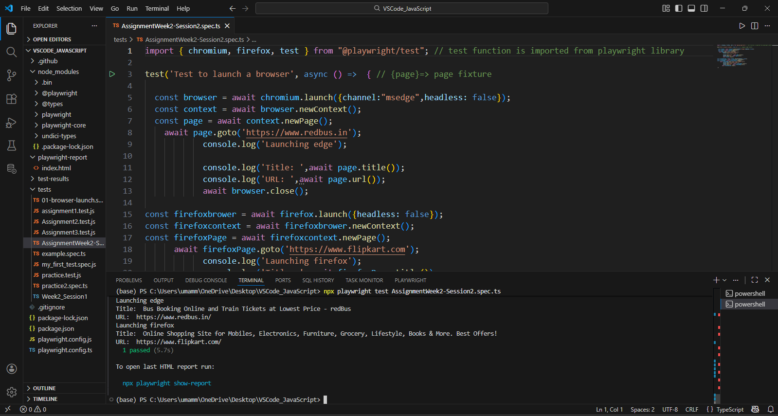
import { chromium, test } from "@playwright/test";

test ('Test to do a basic web automation', async() => {
const browser = await chromium.launch({channel : 'msedge',headless : false});
const context = await browser.newContext();
const Page = await context.newPage();

await Page.goto("http://leaftaps.com/opentaps/control/main");
await Page.locator('[id="username"]').fill('democsr');
await Page.locator('[id="password"]').fill('crmsfa');
await Page.locator('.decorativeSubmit').click();
await Page.locator('[class="crmsfa"]').click();
await Page.locator ('[class="x-panel-tl"]').nth(1).click();
await Page.locator('a[href="/crmsfa/control/createLeadForm"]').click();
await Page.locator('[id="createLeadForm_companyName"]').fill('Electrical Company');
await Page.locator('[id="createLeadForm_firstName"]').fill('Rajesh');
await Page.locator('[id="createLeadForm_lastName"]').fill('SRIDHARAN');
await Page.locator('[id="createLeadForm_personalTitle"]').fill('Mr ');
await Page.locator('[id="createLeadForm_generalProfTitle"]').fill('Software Test Lead');
await Page.locator('[id="createLeadForm_annualRevenue"]').fill('100000');
await Page.locator('[id="createLeadForm_departmentName"]').fill('Software Testing/BA');
await Page.locator('[id="createLeadForm_primaryPhoneNumber"]').fill('9840545160');
await Page.locator('[name="submitButton"]').click();
console.log('Title for the page is ', Page.title());
await Page.waitForTimeout(3000);
}
)

